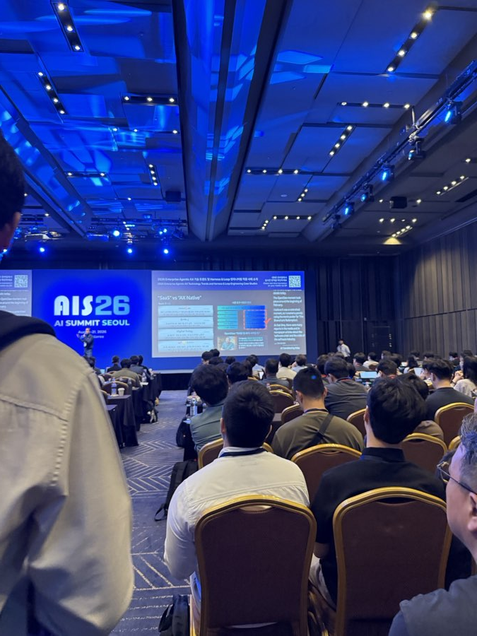
Main stage, AI Summit Seoul (AIS26)
AI Summit Seoul 2026
Session Report — Talks, Panels, and Expo Highlights
Talks & panels: Aug 19-20, 2026 (exhibit floor ran through Aug 21) | Venue: Gramercy Banquet & Convention, Seoul
Sessions logged: 21 talks/panels + 3 expo booths | Source: 231 photos, 8 live-caption sequences, 7 short clips

Each session below is broken into three layers: Highlights (what was actually said/shown), Insight (what it actually means / why it matters), and Takeaway (the one line worth remembering).

If You Only Have 5 Minutes
The five ideas that came up again and again, in plain language.
- Most AI pilots never make it to real use — and it's rarely the AI's fault. Roughly 80% of AI projects never reach full production. The real blockers were messy data, tools bolted onto old workflows, and no senior person willing to approve scaling something up.
- Picking the AI model is the easy part now. Every major AI company (Anthropic, OpenAI, Microsoft, AWS) is now selling hands-on help to actually deploy AI inside a company, not just software access.
- Robots and physical AI need a stricter safety rule than chatbots. A chatbot's wrong answer is annoying; a robot's wrong action can hurt someone. The clearest rule offered: let AI act on its own only where a mistake can be undone.
- Good results always traced back to good data — not a fancier model. Storage, database, and AI companies all said the same thing in different words: organize your data first, or nothing built on top of it works reliably.
- The workforce most comfortable with AI is also the newest. Roughly 30% of the global office workforce is now Gen Z — training built only for senior staff will miss where AI habits are actually forming.

How This Report Was Built — and Where to Be Careful
- Numbers and quotes are the speakers' own claims, passed through live machine translation — treat every statistic as "what the speaker said," not independently verified.
- Some sentences are cut off where a floating app button covered the caption feed, or a photo was blurry. Gaps are left as gaps, not guessed at.
- A few names have uncertain spelling in the captions (marked "name unconfirmed") — worth checking against the official program before external use.
- AI Summit Seoul (AIS26) ran Aug 19-21; the third day (Aug 21) was dedicated to the exhibition floor. This report's talk/panel coverage spans Aug 19-20, plus expo photos captured across the event.

Six Terms Worth Knowing
Agentic AI — AI that doesn't just answer a question, but takes multi-step actions on its own toward a goal.
AX — Shorthand used throughout the summit for "AI Transformation" — enterprise-wide AI adoption, not just one tool.
Harness Engineering — The tooling and guardrails built around an AI model so it can run unsupervised in production.
Sim-to-Real gap — When something that works in a simulator/lab fails once it meets real-world mess (lighting, heat, unpredictable people).
World model — An AI's internal understanding of how physical things behave — the piece robots need that chatbots don't.
FDE (Forward-Deployed Engineer) — A vendor's own engineer embedded inside a customer's rollout, rather than just selling a license.

Day 1 — Foundations & the Enterprise Reality Check
The first day moved from where agentic AI came from, to how far it actually reaches into production today — with two recurring warnings: most AI pilots never scale past a demo, and "Physical AI" is arriving faster than the safety testing built for it.

The Long Road to Agentic AI: A Pioneer's Perspective
선구자의 관점에서 본 AI 어시스턴트에서 에이전틱 AI의 시대
Speaker name not captured on slide | Career: SRI -> Nuance -> Yahoo -> Cortana -> Google Assistant -> Samsung Bixby/Viv -> Georgia Tech
HIGHLIGHTS
- Traced "agentic AI" back to SRI's 1995 Office Assistant — a system that routed speech, email, and calendar requests to specialist agents, the direct ancestor of Siri.
- Argued 2010s-era assistants (Cortana, Google Assistant, Bixby) were deliberately limited, but controllable and fixable when something went wrong.
- Called 2022's ChatGPT moment "the wrong turn": fluent, but the older, more controllable structure was thrown out along with the friction.
- Cited 2026 research: today's agents guess when a task is unclear (89% success with a clear task vs. 6.7% with a vague one) and get stuck repeating their own wrong assumptions in longer conversations.
- Proposed a fix: a much smaller "sidecar" system that checks the model's actual reasoning, plus better real-time back-and-forth — "a meeting of the minds," not more autonomy.
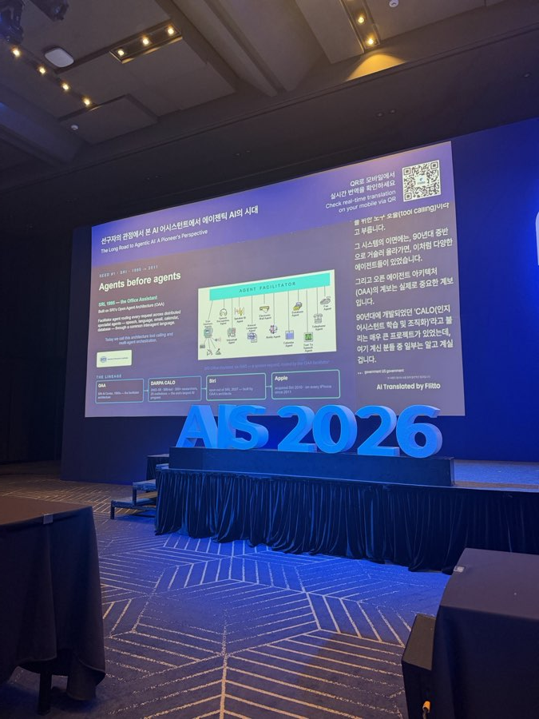
SRI's 1995 "Office Assistant" — presented as the direct ancestor of today's AI agents.
VISION 2030 PILLAR(S): Future Ready
INSIGHT
The pattern here suggests the industry conflated "more fluent" with "more capable." The deliberate constraints older assistants had — a defined belief state, a repair mechanism — weren't limitations to be discarded, they were the parts that made a system auditable. Losing them wasn't progress on every dimension, just on one.
TAKEAWAY
Fluency isn't the same as reliability — a Future Ready test for which AI tools Benilde trusts with real responsibility, not just which ones sound impressive.

Agentic AI in Space: Traditional and Agentic AI Are Revolutionizing Space
지구 밖의 자율 AI: 60개 위성이 스스로 생각하고 협력하는 법
Speaker name not captured on slide
HIGHLIGHTS
- Demoed a workflow that detects an event, automatically picks the right satellites to look at it, and tracks it — shown live with a simulated Mount Pinatubo eruption.
- Framed the goal as "humans on the loop, not in the loop" — people set intent and check results; the system does the coordination.
- Closed on AI that builds its own step-by-step plan from a goal, instead of engineers hand-building a plan for every new situation.
VISION 2030 PILLAR(S): Future Ready
INSIGHT
This model works because satellite tasking has cheap, reversible mistakes (re-point a sensor, try again) and a clear success metric (did we capture the event). Those conditions don't hold everywhere — which is exactly the caveat the Physical AI panel raises later that same evening.
TAKEAWAY
"Set the goal, check the result" is a clean, Future Ready pattern worth borrowing for anything Benilde needs to coordinate across many systems at once — but only where mistakes are cheap to undo.

Is AI Actually Helping Enterprise Productivity?
Featuring Prof. Kyungjong Lee — KB Kookmin Bank / KB Financial Group
HIGHLIGHTS
- Of executives running multiple AI projects, only 6% said the projects moved profit by more than 2% — 94% saw no measurable financial impact.
- A Bank of Korea survey found 60-70% of Korean companies say they're adopting AI, but fewer than 10% report actual results.
- Gartner data: over half of enterprise AI projects get cancelled at the pilot stage, before ever reaching real use.
- KB Financial Group described its own path: its AI-agent platform started development in 2024, launched in April 2025, and is now scaling up.
VISION 2030 PILLAR(S): Financial Growth | Future Ready
INSIGHT
Three independent sources — Gartner, a national bank survey, and this speaker's own executive polling — landed on the same story. That's not cherry-picked pessimism; it's the honest median experience going into 2026, and it should recalibrate how fast any new AI initiative is expected to show ROI.
TAKEAWAY
"Everyone's using AI" and "AI is actually working here" are two very different claims — a Financial Growth and Future Ready distinction Benilde's own pilots should be measured against before budget scales.

2026 Enterprise Agentic AX Technology Trends: Harness & Loop Engineering
2026 Enterprise Agentic AX 기술 트렌드 및 Harness & Loop 엔지니어링 적용 사례 소개
Speaker name not captured on slide
HIGHLIGHTS
- Described a maturity ladder — casual chatbot use, then simple developer tools, then multi-tool platforms, then fully governed enterprise setups — the faster end of that ladder is also the hardest to control.
- Explained "Loop Engineering": design a small loop — set a goal, let the agent try, have it check its own work, fix on failure, stop on success — with a human checking the bigger picture, not every step.
- Covered tools that give AI agents working "memory" across conversations, which most systems still lack by default.
- Closed on a striking fact: Anthropic, OpenAI, AWS, and Microsoft have together committed over $9 billion combined to embedding their own staff inside customers' AI rollouts.
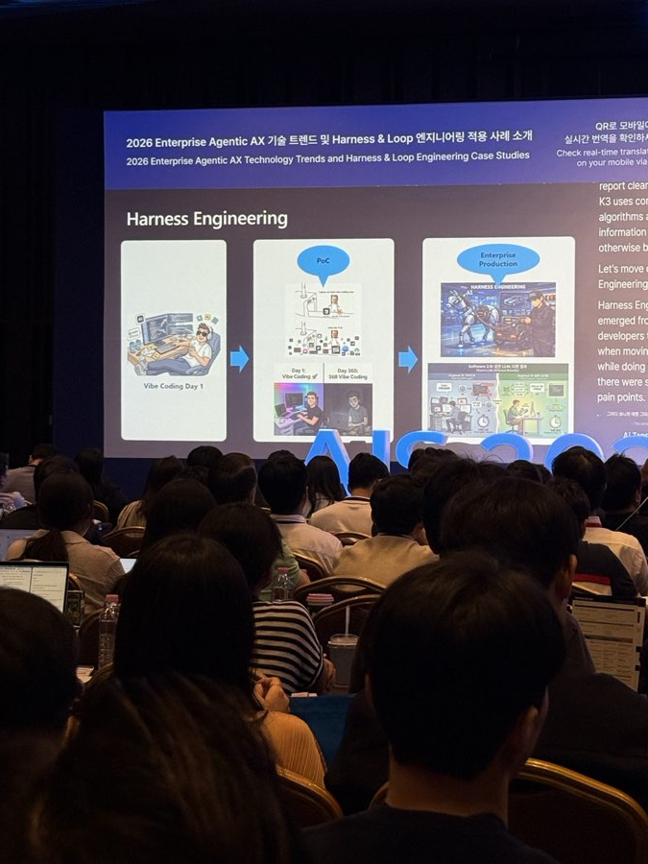
"Harness Engineering" — the missing layer between a weekend prototype and enterprise-grade AI.
VISION 2030 PILLAR(S): Future Ready | Global Partnership Engagement
INSIGHT
Four fierce competitors converging on the identical business model, at the same time, is a strong signal that the model layer has genuinely commoditized. The real competitive edge — and the real lock-in risk — has moved to deployment expertise, not which model a company licenses.
TAKEAWAY
Every major AI vendor now sells hands-on deployment help, not just model access — a Global Partnership Engagement detail worth negotiating into any platform contract Benilde signs, and a Future Ready sign that picking a model was never the hard part.

The Agentic Data Stack: Speed and Simplicity for AI That Scales
ClickHouse
HIGHLIGHTS
- Walked through how AI queries databases changed over 2022-2025: from one predictable request per user, to an AI agent firing off many unpredictable requests at once.
- Shared that OpenAI's daily log data is comparable to "500 Libraries of Congress a day," growing over 20% a month — and Anthropic credited this technology as instrumental in shipping Claude 4.
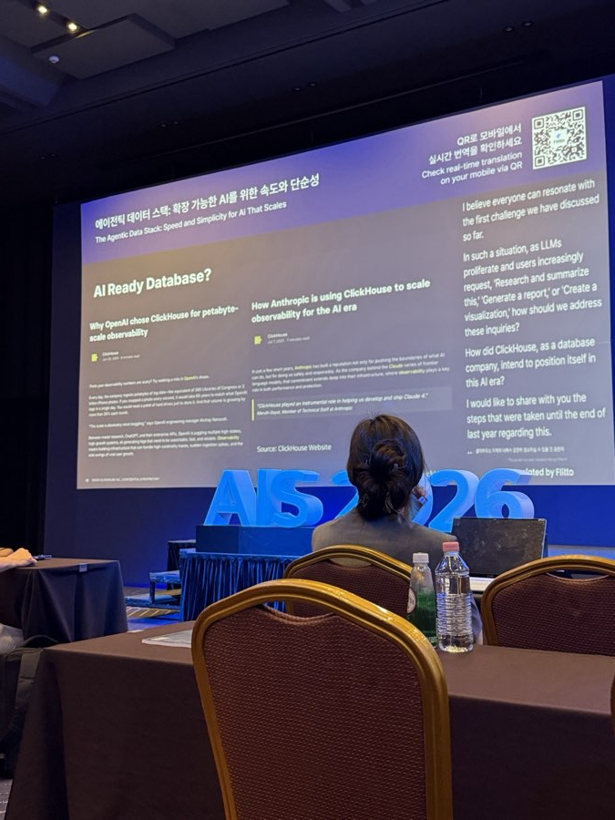
ClickHouse's closing slide, citing its use inside OpenAI's and Anthropic's own systems.
VISION 2030 PILLAR(S): Future Ready
INSIGHT
This shift from predictable to unpredictable query load is a capacity-planning cost most organizations haven't priced into their infrastructure budgets yet — it's a hidden multiplier that shows up only once a pilot actually scales, not during the demo.
TAKEAWAY
AI agents need a database built for many unpredictable requests at once — a Future Ready requirement for Benilde's own data warehouse ahead of any college-wide AI platform decision.

From Models to Reality: What It Takes to Run AI Reliably at Scale
모델에서 현실까지: 대규모 AI를 안정적으로 운영하기 위한 조건
Colin Presly — VP, Customer Engineering, Seagate Technology
HIGHLIGHTS
- Described three stages most companies pass through: can we build something useful, can we run it in production, does it create lasting value. Most are still stuck between the first two.
- Cited data-growth estimates: under 1 zettabyte existed in 2005, 72 in 2020, and a projected 527 by 2029 — with AI training and daily use creating two different, both-growing kinds of demand.
- Noted 85-95% of all AI data ultimately rests on ordinary hard drives, making basic storage density and cost a real lever on AI's overall cost and footprint.
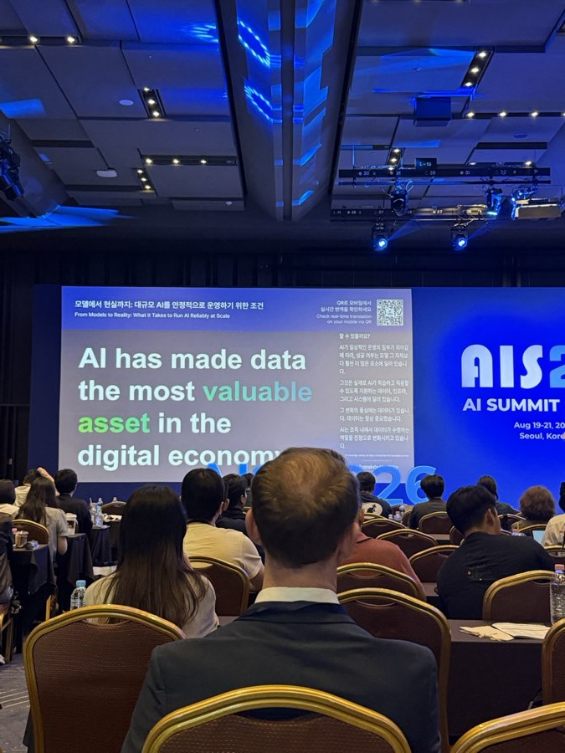
Seagate's closing point: AI made the underlying data itself the scarce, valuable asset.
VISION 2030 PILLAR(S): Financial Growth | Future Ready
INSIGHT
Framing data as "the most valuable asset" is self-serving coming from a storage vendor — but the underlying number is a useful corrective. AI cost conversations fixate on GPU spend; the 85-95%-on-hard-drives figure says storage economics deserve equal attention.
TAKEAWAY
Every AI conversation eventually becomes a data-storage conversation — a Financial Growth and Future Ready reminder that where Benilde's data lives decides what its AI initiatives can actually afford to run.

How AI Is Redefining the Future of Work
AI가 바꾸는 일의 미래
Speaker name not captured on slide
HIGHLIGHTS
- Roughly 30% of the global office workforce is now Gen Z, a group with notably higher entrepreneurial and side-project instincts than earlier generations.
- Noted a Korea-specific detail: mandatory military service and long job-hunting periods push back the age Korean Gen Z workers start full-time roles, versus other countries.
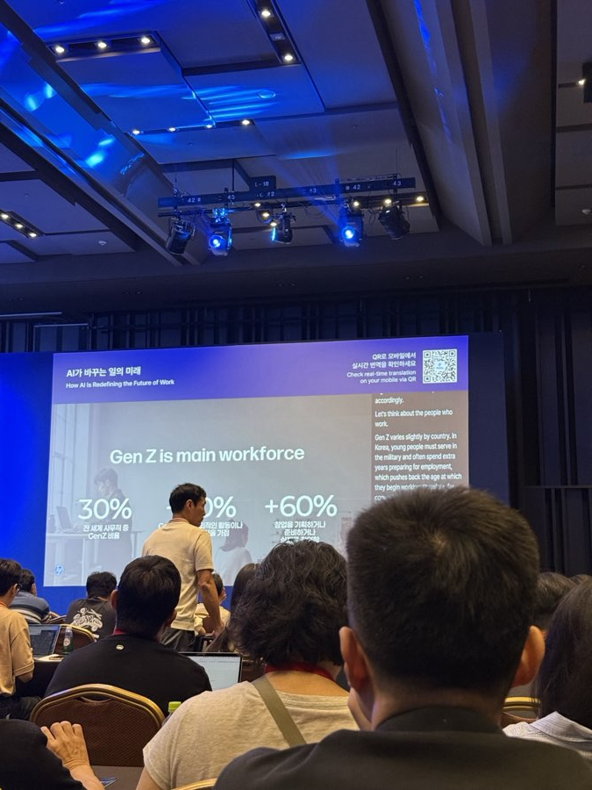
Workforce-composition framing for why AI-native habits are arriving from the entry level up.
VISION 2030 PILLAR(S): Enrollment Growth | Future Ready
INSIGHT
This is really a governance-mismatch warning: policies written by, and for, senior leadership may end up regulating the group least likely to be driving actual day-to-day AI usage on the ground.
TAKEAWAY
AI habits are forming fastest at the newest, least senior level of the workforce — the same cohort Benilde recruits for Enrollment Growth, and a Future Ready reason to design training for entry-level fluency, not leadership alone.

Building as a Creative Act: An Innovator's Mindset for the AI Age
AI 시대의 혁신가의 마인드셋
Savannah Kunovsky — Managing Director, IDEO AI MTechLab
HIGHLIGHTS
- Opening keynote of the afternoon, framed as "the innovator's mindset in the age of AI" from IDEO's AI-focused lab.
- Its framing of embodiment was picked up directly, by name, later that same day in the Physical AI panel.
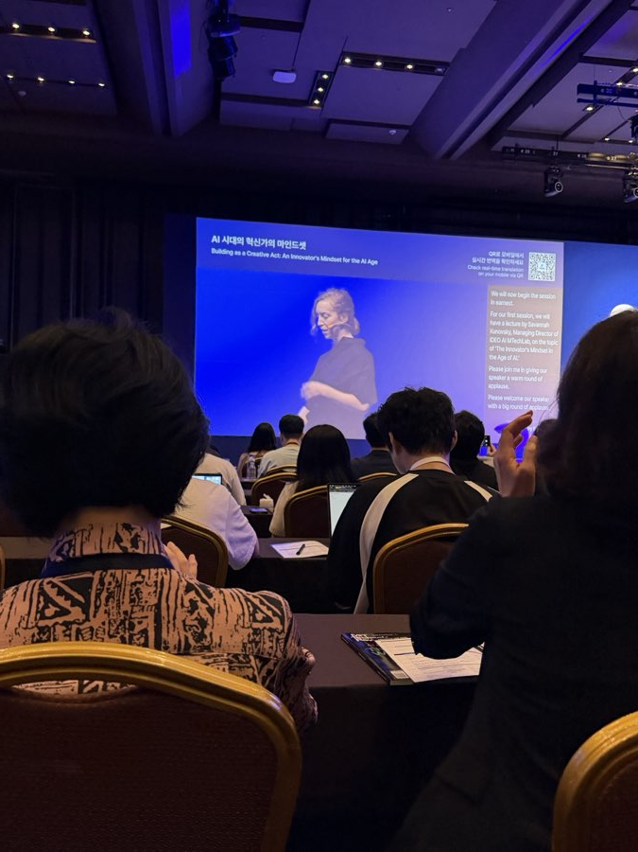
Introduction slide for the IDEO AI MTechLab keynote.
VISION 2030 PILLAR(S): Future Ready
INSIGHT
Keynotes that introduce one reusable concept function as shared vocabulary for the rest of an event. Watching which framing gets picked up by unrelated later sessions — as "embodiment" was here — is a useful signal for what a field is actually converging on, versus what's just one speaker's pet phrase.
TAKEAWAY
"Embodiment" — intelligence that has to act in, and be checked against, the physical world — became this summit's connective thread, and a Future Ready concept worth tracking as AI moves from chat into physical/creative practice.

Beyond Better Models: What Will Define the Next Era of AI?
AI 에이전트의 미래: 더 나은 모델이 아니라 더 나은 워크플로우
Genspark
HIGHLIGHTS
- Shared growth numbers as evidence: $250M in yearly revenue within 12 months from zero, $645M raised at a $2.6B valuation, over 7,000 paying business customers.
- Core message: "better models will keep shipping — the breakthrough is context." Described a "second brain" layer that follows a person across apps.
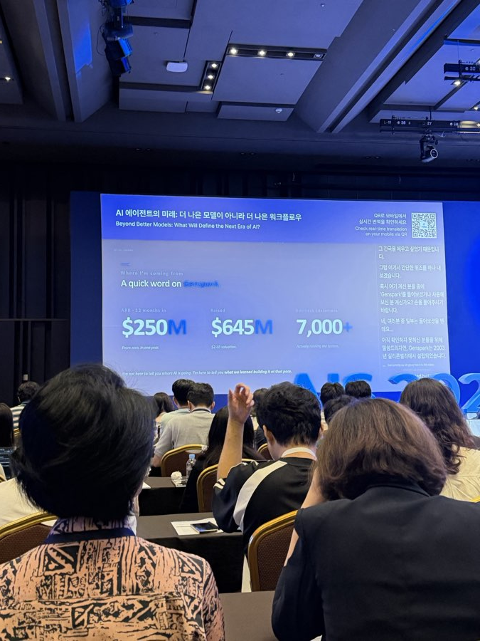
Genspark's growth numbers, offered as evidence for its "context, not bigger models" argument.
VISION 2030 PILLAR(S): Future Ready
INSIGHT
When a vendor's growth pitch and a completely unrelated speaker's opening keynote independently reach the same architectural conclusion hours apart, that's a stronger signal of real market consensus than either claim would be alone — it's less likely to be one company's marketing spin.
TAKEAWAY
Two unrelated speakers, hours apart, reached the same conclusion: a persistent memory/context layer matters more than a bigger model — a Future Ready principle for evaluating any AI tool Benilde considers, regardless of vendor.

The Era of Physical AI: The Future of Industry Transformed by Physical AI
Moderator: Prof. Doohee Jeong (Handong Global University / Impactive AI) | Panelists: Prof. Ahyoung Kim (Seoul National University), Tony Jang (CEO, FactoryLab.AI, ex-Hyundai AutoEver), CTO Seung-young Lee (LIG Defense & Aerospace)
HIGHLIGHTS
- Why now: the turning point traced through AlphaGo, an earlier disappointing wave of AI for robotics (2014-2020), then the technology behind ChatGPT succeeding in language, then vision, then robotics.
- Demo vs. real deployment (Tony Jang): does using it require changing how things already work? Does a failure fit inside normal turnaround time? Is the data needed to keep it accurate clearly someone's job? All three checking out means it's real, not just "a cool demo."
- When is a "world model" real, not marketing? A simulator built on real physics is proven technology; one claiming to perfectly understand physics from scratch is "still at the packaging stage." A described Tesla Optimus incident — misidentifying a coworker as a part and pinning them to a wall — was cited as the real cost of getting this wrong.
- Where should AI's freedom to act stop? (CTO Seung-young Lee): the line is whether the outcome is reversible, not how smart the AI seems. Where a decision can't be undone, AI's job is to hand humans better information faster — not to decide.
- Why lab-tested AI often fails in the real world: roughly half the time it's software (lab conditions don't match reality); the other half is hardware (heat, vibration, signal loss that's hard to simulate).
- Testing under active interference: in defense, the threat is deliberate jamming and deception, not accidental error. The fix: test against a wide range of realistic conditions, keep expanding that range, and treat this as needing government-level involvement.

Humanoid and quadruped robots on the expo floor — "Physical AI" made tangible one floor down from the panel.
VISION 2030 PILLAR(S): Future Ready
INSIGHT
"Reversibility" is a more portable governance principle than most, because it's domain-agnostic and testable in advance — unlike vaguer guidance like "align with our values." It can be applied as a literal checklist question to any proposed AI feature, physical or purely digital, which is why it echoed through several later sessions even outside the robotics/defense context it was coined in.
TAKEAWAY
Use reversibility, not how capable the AI seems, as the line for how much it's allowed to decide — a Future Ready principle directly usable for Benilde's own Mental Health and Academic Advising AI agents.

The Rise of AI-Native Work
AI 네이티브 워크플로우 혁명
Laurent Thevenet — Head of Creative Technology, APAC & MEA, Publicis Groupe
HIGHLIGHTS
- "Instant capability isn't expertise": AI gives fast output, but a person still needs to judge whether it's good and what could go wrong — "the gap is slop."
- Warned against treating "which model for which task" as a strategy on its own — it's plumbing, not transformation.
- Argued the fix for ungoverned tool sprawl is giving people a shared, well-supported set of tools and data, not restricting them.
- Proposed a rule for when a tool needs formal ownership: 5 users, the builder still owns it; 50 users, it needs a named owner; 500 users, it needs a full team.
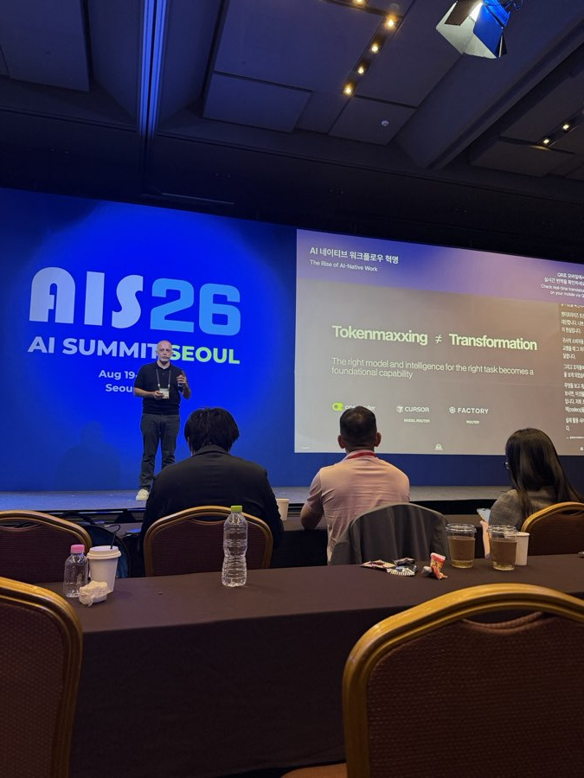
Routing tasks to the "best" model is plumbing, not a strategy on its own.
VISION 2030 PILLAR(S): Future Ready | Financial Growth
INSIGHT
The 5/50/500 rule is really a proxy for blast radius, not raw usage. A tool with 5 users making low-stakes suggestions is a very different risk than 5 users making high-stakes calls — this rule works best paired with the Physical AI panel's reversibility test, not used alone.
TAKEAWAY
A simple ready-made rule for when an internal AI prototype needs formal ownership: 5 users -> the builder; 50 -> a named owner; 500 -> a full team — a Future Ready and Financial Growth check before any of Benilde's own pilots becomes unmanageable.

Day 2 — Industry Deployment & Governance
The second day shifted from "what is agentic AI" to "why doesn't it work yet at our scale" — messy data, change management, and the uncomfortable question of who's actually willing to approve scaling something up.

The Conditions for AX Success and a Truly AI-Native Enterprise
Speaker name not captured on slide
HIGHLIGHTS
- Presented a 4-level scorecard for AI maturity — from occasional tool use to genuine, everyday agentic work.
VISION 2030 PILLAR(S): Future Ready
INSIGHT
That a maturity-model talk earned its own dedicated session suggests the market conversation has matured past "should we adopt AI" into "how do we know if we're any good at it yet" — a healthier, if harder, question.
Captured only in slide/photo form; caption detail for this talk wasn't fully recovered from the source images.

Accelerating Breakthroughs with AI: Unlocking Opportunities in Traditional Industries
Ramine Tinati — Head of APAC, Google DeepMind | Moderator: Seri Kim
HIGHLIGHTS
- Opened with DeepMind's science-first roots (the AlphaGo match, played in Seoul a decade ago), then its non-chatbot track record: AlphaFold (200M+ protein structures, now free even commercially), a materials-science model with 2.2M predicted crystal structures, and weather-forecasting tools.
- Repeated the central statistic: roughly 80% of AI projects never reach full production — a systems problem, not a "model isn't smart enough" problem.
- Why pilots stall: scattered/unusable data, AI added on top of a workflow instead of built into it, and cultural resistance (no one senior owning it).
- Four fixes: get the data solid and verified first; keep re-checking AI against how the industry actually talks; build AI into daily tasks, not just chat; put real safety/oversight checks in place.
- Named three industries with the most room to benefit: healthcare/life sciences, manufacturing/supply chain, and telecom/infrastructure.
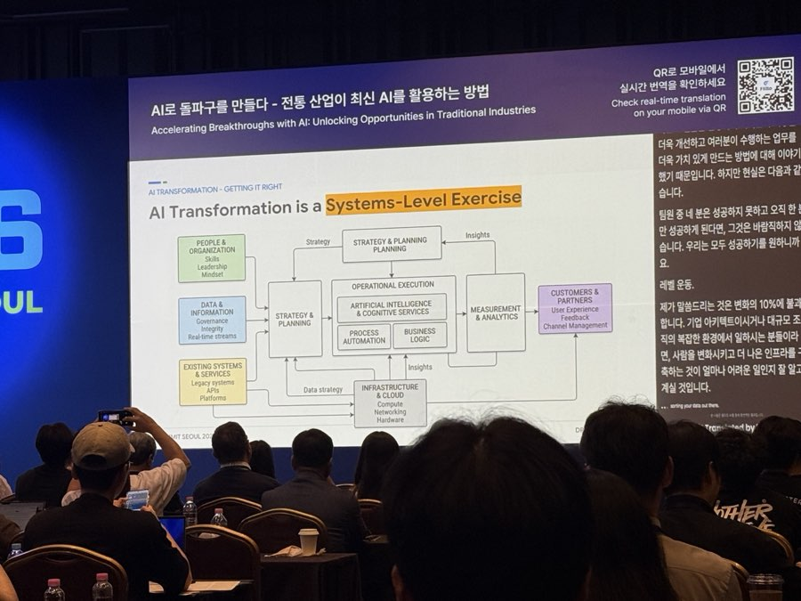
DeepMind's framing: AI transformation succeeds or fails as a systems-level exercise.
VISION 2030 PILLAR(S): Future Ready | Global Partnership Engagement
INSIGHT
Opening with the slowest-to-monetize, most scientifically credible work — rather than a flashy chatbot demo — is itself a deliberate rhetorical strategy: it positions rigor as the differentiator in a market currently saturated with unverified demos.
TAKEAWAY
The summit's most-repeated number — 80% of AI projects don't reach production — traces back to data readiness, a Future Ready lesson directly applicable to Benilde's Phase 2 pilots, and a Global Partnership Engagement opening given DeepMind's free academic-tier tools.

The Present and Future of Payment in the Age of AI
AI 기술과 만난 결제(Payment)의 현재와 미래
Sunghee An — Executive Director, Shinhan Card AX Research Institute
HIGHLIGHTS
- Mapped the competition across four player types: AI companies partnering into payments (OpenAI + Stripe, Google), existing wallets (KakaoPay, NaverPay, Samsung Pay), online retailers (Amazon, Walmart), and card networks (Mastercard, Visa).
- Introduced Shinhan's own "Agent Pay" pilot — AI agents managing payments on a customer's behalf.
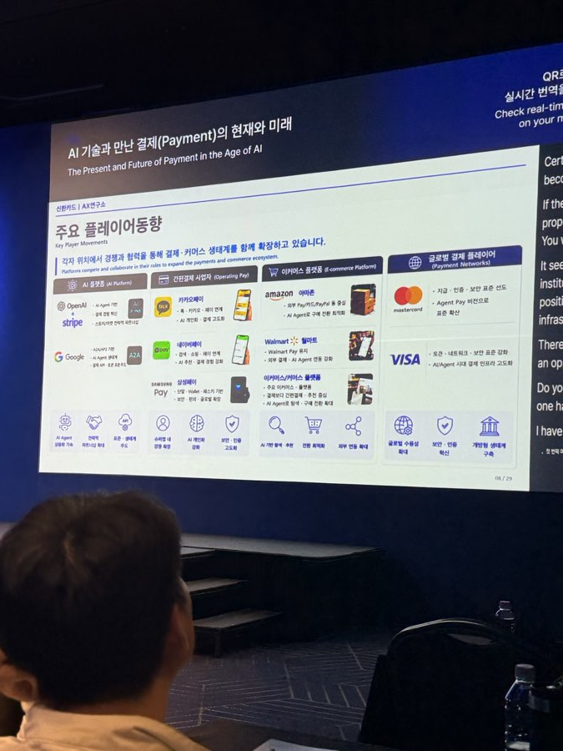
Shinhan Card's map of AI entering payments from four directions at once.
VISION 2030 PILLAR(S): Financial Growth | Global Partnership Engagement
INSIGHT
When four structurally different types of competitors move into the same space at once, it usually signals the opportunity is real — but also that the eventual standard or winner is genuinely unsettled. Worth watching, not urgently acting on.
TAKEAWAY
Payments is a preview of what's coming to every trust-sensitive process — a Financial Growth and Global Partnership Engagement signal worth watching as fintech and AI platforms converge.

Decisions vs. Tasks: What Agentic AI Actually Means in Operations
Prent Mishra
HIGHLIGHTS
- Captured via stage/slide photos only; the full argument wasn't recovered from the source images.
VISION 2030 PILLAR(S): Future Ready
INSIGHT
Even from a thin record, the framing itself matters: distinguishing "automating a task" from "delegating an actual decision" is the exact vocabulary the Physical AI panel's reversibility principle needs to be applied inside a real workflow.
Worth following up on if a fuller recording turns up.

Panel: Hidden Bottlenecks in Enterprise AI — Data Quality, Governance, and Reality
Moderator: name unconfirmed ("Seunghyun"/"Seunghwan" Lee), VP, Samil PwC | Yongmin Choi, Head of AI Strategy Center, Woori Financial Group | Yoonhee Hwang, Senior VP, Data Intelligence, LG Electronics
HIGHLIGHTS
- Named the real bottleneck of the last 2-3 years as that exact moment — someone senior has to approve scaling a pilot that already works.
- Used a gold-rush comparison: in past tech waves, the money went to companies selling infrastructure, not most people trying to use it.
- Debated whether AI agents should be managed like software accounts or like digital employees with defined roles — an open question.
- LG Electronics described a common trap: a "plain-English database search" tool that worked great in testing broke down once scaled to thousands of real tables.
- Closing advice: pair every AI rollout with an actual redesign of the process and people's roles — don't just bolt AI onto how things already work.
VISION 2030 PILLAR(S): Future Ready | Financial Growth
INSIGHT
The "who presses the button" problem and LG's specific technical failure (context overload as tables scale) likely compound each other: a technically shaky pilot makes leadership even less willing to approve scaling, and that hesitation delays the data-engineering fix that would have made it stable. It's a cycle that starts with data work, not executive courage.
TAKEAWAY
Executive hesitation — not data or model quality — was named as the single biggest bottleneck. It's a Future Ready and Financial Growth governance problem the Digital Transformation Office should own explicitly, per the roles framework below.

Panel: AI Governance in Manufacturing
Three panelists, names not captured in the recovered transcript
HIGHLIGHTS
- Named the core difficulty as turning knowledge that lives only in experienced staff's heads into shared, written data.
- Raised real cost pressure from cheaper competitors and the difficulty of hiring skilled on-site staff internationally as reasons manufacturers are turning to AI.
- Closed with a candid point: when agents absorb roughly half a team's old workload, the goal isn't to cut the team — it's to move them to work the tools still can't do.
VISION 2030 PILLAR(S): Future Ready
INSIGHT
"Turning tacit knowledge into data" is functionally the same problem manufacturers have always had with retiring experienced staff and lost institutional memory. AI didn't create this problem — it just raised the cost of continuing to not solve it.
TAKEAWAY
Writing down tacit, expert-only knowledge is the unglamorous but unavoidable first step before any manufacturing AI can be trusted — a Future Ready lesson for any Benilde department piloting AI on top of undocumented expert know-how.

Agentic AI Strategies for Building Digital Resilience
디지털 레질리언스 구축을 위한 에이전틱 AI 전략
Cisco
HIGHLIGHTS
- Presented a shared data pipeline routing machine/system data into one low-cost store, then feeding AI training, compliance, security monitoring, incident response, and everyday AI agents from that single source.
- Made the same point as the DeepMind talk from a different angle: one well-governed data foundation is the prerequisite for AI and security to work well together.
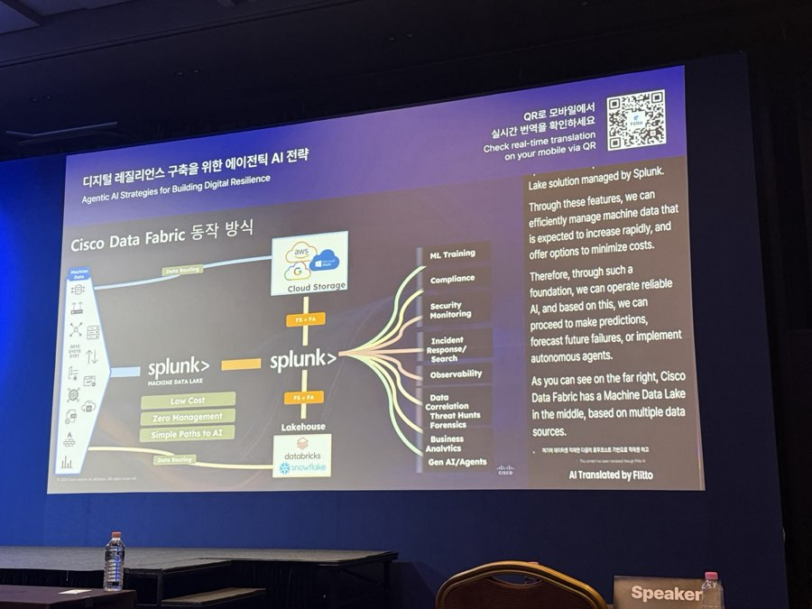
One shared data foundation feeding security, compliance, and AI agents alike.
VISION 2030 PILLAR(S): Future Ready | Enhanced Reputation and Branding
INSIGHT
Routing security and AI use cases through the same data pipeline is efficient, but it also means a security incident and an AI-agent failure will increasingly surface in the same monitoring system — worth deciding in advance who owns a cross-cutting incident before one actually happens.
TAKEAWAY
Cybersecurity readiness and AI-agent readiness are converging on the same requirement — a Future Ready foundation that also protects Benilde's Enhanced Reputation and Branding position as a trustworthy institution.

From Intuition to Intelligence: How AI Has Redefined Revenue Growth
세일즈 과학의 혁명: AI는 영업을 어떻게 바꼈는가
Barra O Briain — Head of APEC Sales, Gong
HIGHLIGHTS
- Cited a PwC study: 74% of AI's business value goes to just 20% of companies — because they redesigned how they work around it and invested in more oversight, not less.
- Contrasted an 88% AI-adoption figure with a separate finding that 60% of AI projects are on track to miss their goals — "everyone has the tool, almost no one has the value."
- Proposed a formula for a real AI win: time saved times how much better the actual outcome is. Most companies stop at the "time saved" half.
- From analyzing millions of real sales calls: top-performing reps talk about 46% of the time versus 68% for average reps, and wait until later in the call to discuss price.
- Cited customer results: roughly 10 hours a week given back per rep, 46-50% less time to ramp up new hires, and a self-reported 64% jump in productivity — with Anthropic named as one customer.
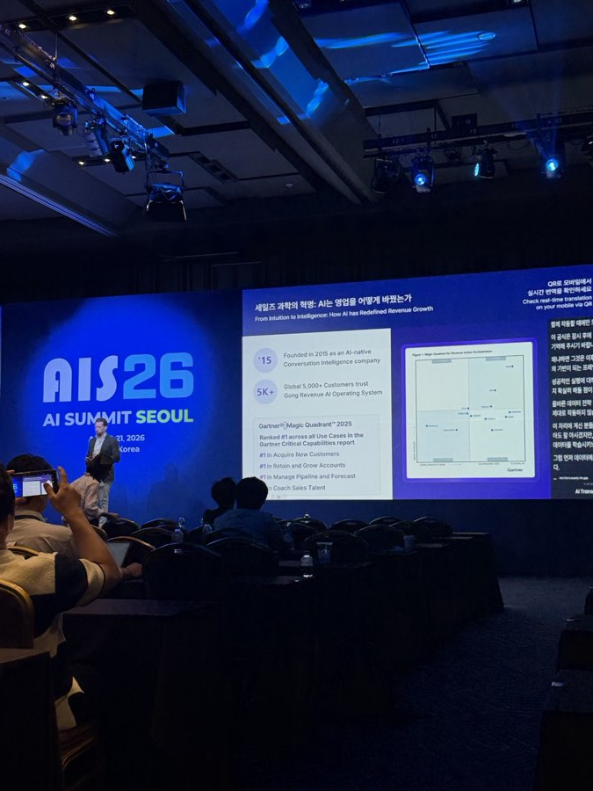
Gong's closing credibility slide — company stats and industry-analyst rankings.
VISION 2030 PILLAR(S): Enrollment Growth | Financial Growth
INSIGHT
The formula is easy to state and hard to actually measure: "effectiveness" requires agreeing on what outcome you're optimizing for, and most organizations haven't had that conversation before buying the tool — which is exactly how you end up only measuring the efficiency half.
TAKEAWAY
"Time saved times outcome improved" is a simple check directly applicable to Benilde's Enrollment Growth funnel (the Recruitment Chatbot, the Academic Advising Agent) and a Financial Growth discipline for reporting any AI tool's real value to the Board.

Expo Highlights
Throughout both days - Expo Floor
HIGHLIGHTS
- FAIN Robotics x AGIBOT — humanoid and quadruped robots on live demo, the most direct physical illustration of "Physical AI" on the show floor.
- Golden Gate University — a fully online doctorate in Applied & Agentic AI for working AI practitioners.
- Foretell My Health — a blood-based AI cancer-screening startup, starting with ovarian cancer risk.

Humanoid and quadruped robots on display at the expo floor.
VISION 2030 PILLAR(S): Enhanced Reputation and Branding | Global Partnership Engagement

Closing line from the live feed: "Thank you once again for your insightful presentation. This concludes all the sessions of AI Summit Seoul 2026."

Four Ideas That Kept Coming Back
Across all 21 sessions, regardless of industry or track, these four points kept resurfacing.

1. Most AI pilots die before real use — and it's rarely the AI's fault
From the morning talk (94% saw no profit impact) to DeepMind's "80% never reach production" to the "who presses the button" problem: messy data, tools bolted onto old workflows, and hesitant leadership were named as the real blockers across five separate sessions on three different tracks.
2. The hard part moved from "which model" to "how do we actually run this"
The maturity ladder for AI tools, the $9B+ race among major vendors to embed engineers in customer rollouts, and the "routing tasks to the right model isn't a strategy" warning all point the same way: picking a model is the easy part now.
3. Physical AI needs a stricter safety bar than software AI
The Physical AI panel's "can it be undone?" rule, and its "test a wide range of conditions, not a fixed checklist" answer, echoed in the manufacturing panel's caution and in Seagate's storage-reliability framing. Once AI acts in the physical world, a mistake stops being "a wrong answer" and becomes "an accident."
4. Good data is the prerequisite everyone agreed on, independently
ClickHouse, Seagate, DeepMind, Cisco, and the manufacturing panel all named the same prerequisite in different words: get the data organized and governed first, or nothing built on top works reliably.

Vision 2030 Alignment: Who Makes This Real
The ideas above are only useful if someone owns turning them into action. This section maps the summit's themes onto the five strategic pillars from the Vision 2030 roadmap discussion — with a specific office or role named against each recommendation, because the summit's own most-repeated failure mode was exactly this: no one senior owning the decision to act. Treat the office names below as a starting proposal, not an already-approved assignment.

1. Enrollment Growth
Give the Recruitment Chatbot persistent context across a prospect's full journey (inquiry -> application -> enrollment). Apply the reversibility test to the Academic Advising Agent now, while it's still in development: advising nudges are AI-assisted; anything hard to undo (probation, drop recommendations) stays human-decided.
RESPONSIBLE: Center of Educational Technology (CET), with Admissions for the chatbot; Academic Council for advising-agent guardrails.
2. Enhanced Reputation and Branding
Publish a first AI case study once Phase 2 pilot results land, honest results included. Brand Benilde's public AI position around governance discipline specifically, not raw capability.
RESPONSIBLE: Marketing & Communications, with CET for content; Office of the Chancellor for public positioning.
3. Future Ready
Add the three-question go/no-go gate (system change needed? failure fits cycle time? retraining data clearly owned?) to every Phase 2 pilot before it's proposed for Phase 3 scale-up. Confirm the data warehouse can handle agentic query load before the college-wide platform is selected.
RESPONSIBLE: CET and Academic Council for the go/no-go gate; CET / IT infrastructure for the data warehouse review.
4. Global Partnership Engagement
Require every shortlisted Phase 2 platform vendor to disclose what deployment support is bundled into their contract. Scope one applied-research partnership with a lab offering free academic-tier tools.
RESPONSIBLE: CET and Procurement for vendor terms; Office of the Chancellor and academic deans for research partnerships.
5. Financial Growth
Report Phase 2 pilot results to the Board on both efficiency and effectiveness, not adoption numbers alone. Release Phase 3 scale-up budget in gated tranches tied to Phase 2 evidence, not as one lump commitment.
RESPONSIBLE: CET and Finance for reporting format; the Board / Leadership Team for gated budget release.
WHO LEADS THIS, OVERALL
A single accountable office, not a rotating committee, is what turns the five rows above from a wish list into a plan. Proposed lead role: a Director, Office of AI-Enabled Transformation (new or an elevated existing role), reporting to the Office of the Chancellor, with the Center of Educational Technology as its operating arm. Decision authority: that Director applies the go/no-go gate above and recommends scale-up; the Chancellor's Office holds final sign-off on anything budget-significant or reputationally sensitive. Naming this now, in writing, before the first pilot is ready to scale, is what prevents the summit's single most common failure: a good pilot that never finds anyone willing to press the button.

POSSIBLE BUDGET SOURCES
- An institutional strategic/innovation fund or a Board-approved capital line, released in gated tranches tied to pilot results.
- Reallocation within the existing IT/EdTech operating budget as lower-value tools are retired.
- Vendor/partner co-investment — several AI vendors now bundle deployment support into platform contracts at no extra cost.
- External grants or partnership funding, including through existing research-partner relationships.
- Philanthropic or alumni giving earmarked for innovation, worth a joint feasibility check with Advancement.

AI Implementation: Roles & Responsibilities
The summit's clearest lesson was that roles without a decision path just recreate the "ad hoc committee" problem the Vision 2030 roadmap already flags. Below is a proposed model for who does what, and who ultimately decides.

1. Digital Transformation Office (Program Lead)
The orchestrator, not the builder of everything.
- Owns the roadmap's cadence and the master pilot list — the one place that can see across IT, CET, and Academic Affairs at once.
- Runs the three-question go/no-go gate on every pilot before it's proposed for scale-up.
- Prepares Board/BLT reporting on both efficiency and effectiveness, not adoption numbers alone.
- Escalates anything hitting the reversibility line to Leadership — does not decide it alone.

2. IT Team
The infrastructure and safety net.
- Owns the data-warehouse / agentic-query-capacity question before any platform is selected college-wide.
- Runs security review on every AI vendor: data residency, access scope, breach exposure.
- Owns uptime and support once a pilot graduates from CET's hands into daily operations.

3. Innovation & EdTech (Center of Educational Technology)
The pedagogical and use-case owner.
- Vets tools against the EdTech AI Tools Guide rubric before anything reaches a classroom or advisor.
- Runs the actual pilots (syllabus AI, Academic Advising Agent, Mental Health Agent) and reports results.
- Owns faculty and student training under the AI Literacy Framework.

4. Leadership (VP for Admin & Innovation, Office of the Chancellor, BLT)
The risk owner and budget releaser — the "who presses the button" role the summit's most-repeated failure mode says usually goes unfilled.
- Signs off on anything budget-significant or reputationally sensitive.
- Releases Phase 3 scale-up funding in gated tranches tied to Phase 2 evidence, not as one lump commitment.
- Sets the non-negotiable boundary: which decisions, per the reversibility test, never become AI's call no matter how well a pilot performs.

5. Other School Leaders (Academic Council, Deans/Program Chairs, Finance, Marketing & Comms, Student Affairs)
The domain implementers — a pilot that works in CET's hands still needs a Dean or Program Chair to make it standard practice.
- Academic Council: policy guardrails for anything touching grading, advising, or academic integrity.
- Finance: the efficiency-times-effectiveness reporting format, and sign-off on budget tranches.
- Marketing & Communications: the public "governance discipline" narrative.
- Student Affairs: co-owns the Mental Health Agent given its stakes.

THE DECISION PATH
CET pilots -> Digital Transformation Office runs the go/no-go gate -> IT signs off on infrastructure/security -> Leadership approves scale + budget -> the domain leader owns rollout in their unit. Any step that hits the reversibility line routes to Leadership regardless of how well the pilot tested.

Record of Preparation
Reconstructed from on-site photos and Flitto live-translation captures of AI Summit Seoul (AIS26), Aug 19-21, 2026 (talks/panels Aug 19-20; exhibit floor through Aug 21). Speaker names, exact figures, and quotes should be checked against an official recording or transcript before external use. See "How This Report Was Built" for full sourcing caveats.

Recorded by:
Lea S. Abarentos
Program Lead - Digital Transformation Office
Date: August 23, 2026

